***…WOW, full !***

**Title Captive on PBRC**

**Algae Cultivator to SDG Y.x**

**SDG Y.x what get by PBRC ? (Photo Bio Reactor Continuous)**

**Algae Cultivator - PBRC toward SDGs/UN Y.x** (Target Y.x - …By 2030, ensure universal access to affordable, reliable and modern energy services).

Summary

**J W T 2**

**Bibliography/Conclusion 2**

Algae Cultivator from SDGC (source) : 3

Summary – Applications (to SDGs) 5

International Application Status Report 11

# J W T

### [****joules****](http://www.expotv1.com/JWT_project.pdf) [****water team****](http://www.expotv1.com/JWT_project.pdf)

[***https://www.jwt-jwt.it/***](https://www.jwt-jwt.it/)

**Subject to the NDA, consultancy and appropriate industrial property rights are available;**

( [**INNOVATION**](http://www.expotv1.com/LIC/BUNIT/LISTV.ASP) - [Patents and Projects, with relevant BPs and StartKit Commercial Offers](http://www.expotv1.com/LIC/BUNIT/LISTV.ASP)  )

**JWTeam**

<http://www.expotv1.com/ESCP_NUT_Team.pdf>

*Offers extensive support on* ***Energy*** *and* ***Water Cycle,*** *verse* [**IP_S DGs /UN**](http://www.expotv1.com/JWT_to_SDG_UN.pdf)

# Bibliography/Conclusion

Any reference to people and things is purely coincidental, as well as creative/imaginative and aimed at the common good (both in fiction and non-fiction/disclosable texts). The Owners/Inventors of the Editorial rights on the source Intellectual Property believe the contents do not misrepresent the essential objectives, aimed to disclose, but above all promote the official sources cited in the bibliographies. Patents are archived, granted and owned by authors who have issued the necessary editorial permissions. Each patent is well founded (legitimized by the relevant national legal bodies: UIBM/IT, EPO/EU, WIPO/UN, EAPO/RU, CNIPA/CN, InPASS/IN), well understandable to professionals, and usable according to case law in vogue; [**JWTeam**](http://www.expotv1.com/ESCP_NUT_Team.pdf) reviews and oversees the dissemination of [**SDGs/UN**](https://sdgs.un.org/goals), pronouncing itself with the pseudonym "**Ghost GREEN**".

# Algae Cultivator from PBRC (source) :

Patent:

[**PBRC**](http://www.expotv1.com/LIC/UIBM_PBRC.pdf) ,[**https://patentscope.wipo.int/search/en/detail.jsf?docId=WO2016092583**](https://patentscope.wipo.int/search/en/detail.jsf?docId=WO2016092583) (algae to food/feed/biofuel, in urban and periurban); [view1](https://www.bing.com/images/search?q=%28algae+to+food%2ffeed%2fbiofuel%2c+in+urban+and+periurban%29&FORM=HDRSC2)

Italy: GRANT

<http://www.expotv1.com/LIC/MISE_0001427412_PBRC.pdf>, ...mean "INDUSTRY (useful), NEW (no make before), INVENTIVE (teach some things)"mean "INDUSTRY (useful), NEW (no make before), INVENTIVE (teach some things)".

**Abstract/Description -** Patent:

[**PBRC**](http://www.expotv1.com/LIC/UIBM_PBRC.pdf) ,[**https://patentscope.wipo.int/search/en/detail.jsf?docId=WO2016092583**](https://patentscope.wipo.int/search/en/detail.jsf?docId=WO2016092583)

**Full Intellectual Property**

[**http://www.expotv1.com/ESCP_Patent.htm**](http://www.expotv1.com/ESCP_Patent.htm)

**Full JWTeam Service**

[**http://www.expotv1.com/PUB/JWT_Service_EN.pdf**](http://www.expotv1.com/PUB/JWT_Service_EN.pdf)

# Summary – Applications (to SDGs)

[**PBRC**](http://www.expotv1.com/LIC/UIBM_PBRC.pdf)

[**https://patentscope.wipo.int/search/en/detail.jsf?docId=WO2016092583**](https://patentscope.wipo.int/search/en/detail.jsf?docId=WO2016092583)

**MicroAlgae - generate oleic and protein components for Bio-Fuel and Feed / Food . PBRC** is dedicated to algal cultivation, both for purposes useful for the oleic supply chain (energy, biodiesel, hydrogen , ...) and the protein supply chain ( feed / food , cosmetics, pharmaceuticals, ...). Very compact system that uses only renewable energy, with large specific growth indices. with great flexibility and penetrability even towards urban and peri-urban settlements . Excellent solution for CO2 capture and disposal of NPK salts deriving from other processes (e.g. anaerobic digesters) . It offers significant contrast in load　inorganic from　metals contributing to performance on　" **Water cycle** ".

**Project:** PBRC – Phto Bio Reactor Continuous

**Objective :** Launch a pre- assembly and testing site (procedures and manuals) for the production of tanks

**Target:** Prefabricated (CLS) companies, Operators in the power LED sector, Hydromechanics companies , Financial investors, Operators in the AGRO and BioGas / BioMethane sector

The project aims to activate a production site, from design to assembly (pro delivery and rapid assembly), with the development of production-oriented procedures agreed with the client (based on the products available for supply) and destinations of the outputs produced. The solutions rely on standard products from the water management and prefabricated market, LED products integrated with RES, assembled and tested with a view to optimizing the cultivation of algal strains functional to the commissioned objectives. In collaboration with internal and external laboratories, it will act as remote support for the installations in charge (EPC - Engineering , Procurement and Construction ).

**Summary:** The proposed method consists of the following steps; an aqueous mixture containing an inoculum, i.e. a small quantity of microalgae to be cultivated, is introduced into a tank divided into two parts by a bulkhead . The mixture follows a sinuous path in the first part of the tank, along which it is irradiated by a radiation spectrum suitable for the development and growth of microalgae. NPKx salts (containing nitrogen, phosphorus and potassium) and CO2 are also added along the way , which promote algal growth. The mixture, highly enriched with microalgae, passes into the second part of the tank, where it is subjected to ultrasound which destroys the algae, separating them into oleic and protein components. This action causes the formation of a new aqueous mixture in which there is an oleic fraction, a protein fraction and a neutral fraction. The new aqueous mixture undergoes a spontaneous gravimetric separation in such a way that: a) the lighter oleic fraction migrates to the upper part of the new mixture; b) the heavier protein fraction migrates to the lower part of the new mixture; c ) the neutral fraction, composed almost exclusively of water, remains in the intermediate part of the new mixture. The three fractions are taken separately. The neutral fraction is recycled containing inoculum for the starting aqueous mixture. The proposed device includes: a) a tank designed to contain the aqueous mixture; b) one or more bulkheads designed to delimit a path from an entry point to an exit point, said bulkheads being homogeneous diffusing panels of a radiative spectrum suitable for the cultivation phase; c) means designed to supply the fluid mixture with NPK salts (salts containing nitrogen, phosphorus and potassium) and CO2, said means being arranged along said path; d) means designed to produce ultrasounds, positioned at the final point of said path, said ultrasounds being of sufficient power to destroy the algae by separating them into oleic and protein components, giving rise to a new fluid mixture in which an oleic phase, a protein and a neutral phase; e) means designed to spread said new fluid mixture, in order to carry out a gravimetric separation of said oleic, protein and neutral phases; f) means designed to separately collect the said oleic, protein and neutral phases.

This method and device have some advantages over traditional microalgae cultivation and extraction techniques. For example:

•  They reduce the space required and adapt to urban and suburban logistics;

•  They mainly exploit renewable and environmentally friendly energy sources;

•  They obtain high growth rates and a continuous production cycle of the oil and protein fractions;

•  They avoid the mechanical movement of the algal mass and its exposure to environmental thermal cycles;

•  They limit the risks of biological and chemical contamination from the environment.

[***SDGs / UN_en***](https://sdgs.un.org/goals) ***-*** [***SDGs / UN_it***](https://sdgs-un-org.translate.goog/goals?_x_tr_sl=en&_x_tr_tl=it&_x_tr_hl=it&_x_tr_pto=wapp) ***Full Strategy to***

[***1***](https://sdgs.un.org/goals/goal1)[***2***](https://sdgs.un.org/goals/goal2)[***3***](https://sdgs.un.org/goals/goal3)[***4***](https://sdgs.un.org/goals/goal4)[***5***](https://sdgs.un.org/goals/goal5)[***6***](https://sdgs.un.org/goals/goal6)[***7***](https://sdgs.un.org/goals/goal7)[***8***](https://sdgs.un.org/goals/goal8)[***9***](https://sdgs.un.org/goals/goal9)[***10***](https://sdgs.un.org/goals/goal10)[***11***](https://sdgs.un.org/goals/goal11)[***12***](https://sdgs.un.org/goals/goal12)[***13***](https://sdgs.un.org/goals/goal13)[***14***](https://sdgs.un.org/goals/goal14)[***15***](https://sdgs.un.org/goals/goal15)[***16***](https://sdgs.un.org/goals/goal16)[***17***](https://sdgs.un.org/goals/goal17)[**SDGs/UN**](http://www.expotv1.com/JWT_to_SDG_UN.pdf)

[***http://www.expotv1.com/ESCP_Hello.htm***](http://www.expotv1.com/ESCP_Hello.htm)

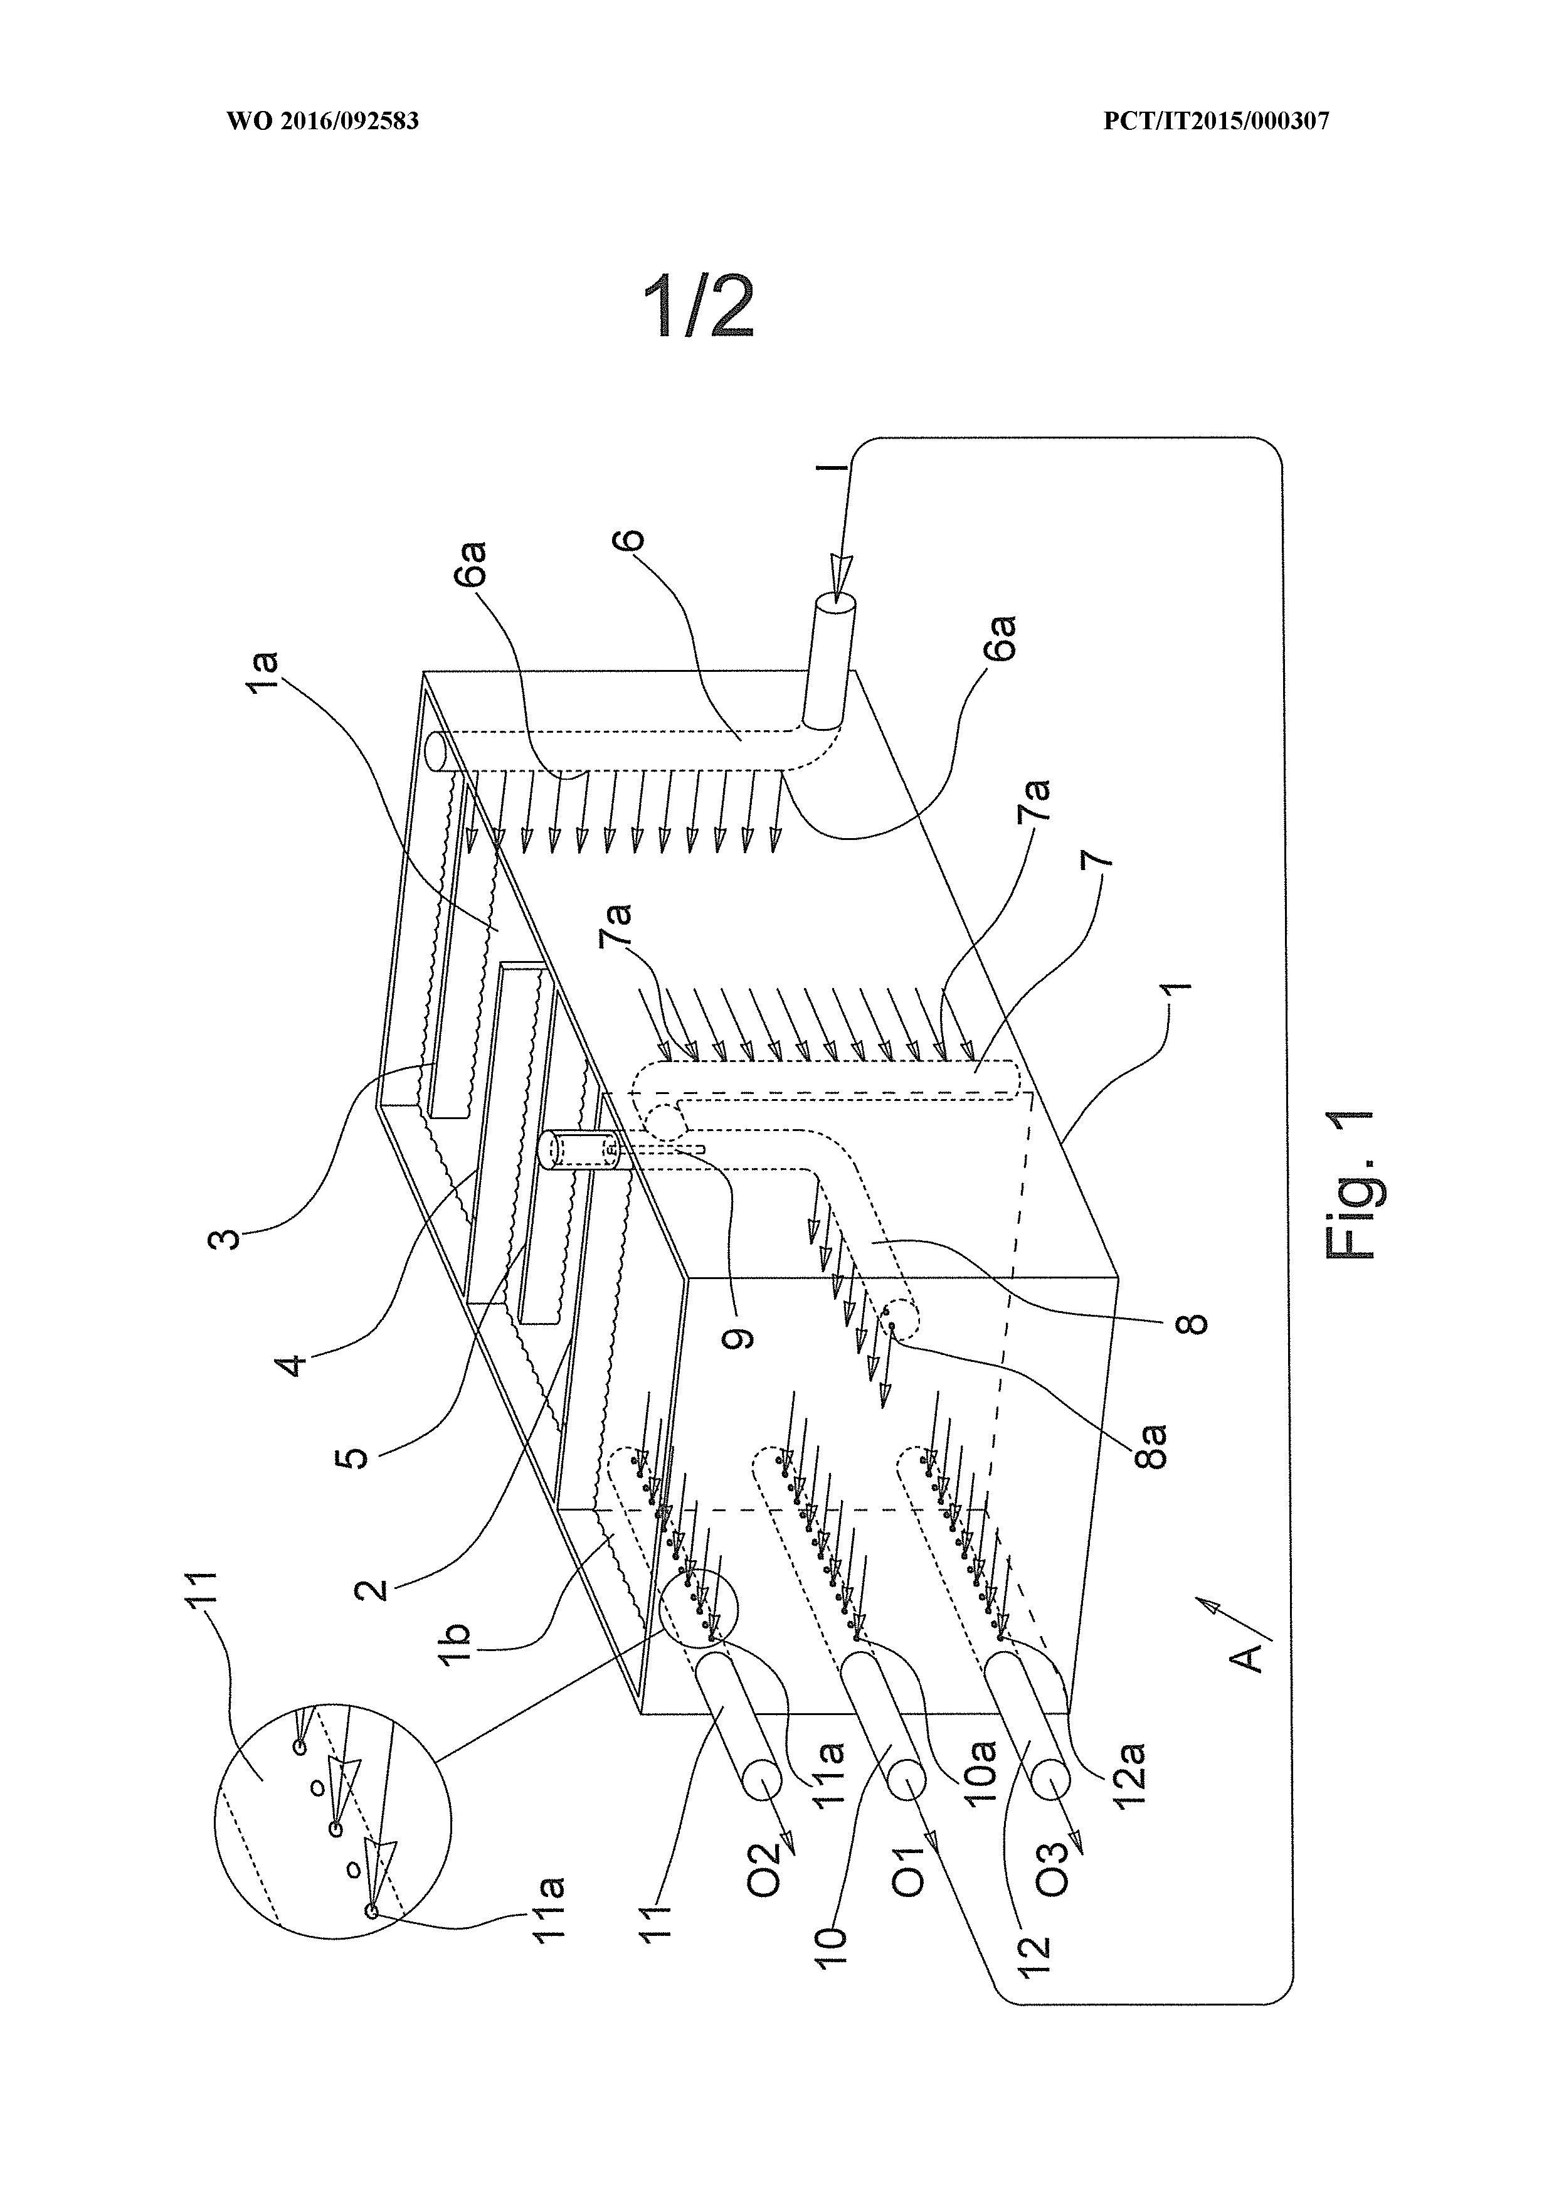

# IASR International Application Status Report

Received at International Bureau: 01 February 2016 (01.02.2016)

Information valid as of: 17 June 2016 (17.06.2016)

Report generated on: 30 September 2023 (30.09.2023)

(10) Publication number: (43) Publication date: (26) Publication language:

WO 2016/092583 16 June 2016 (16.06.2016) English (EN)

(21) Application number: (22) Filing date: (25) Filing language:

PCT/IT2015/000307 14 December 2015 (14.12.2015) Italian (IT)

(31) Priority number(s): (32) Priority date(s): (33) Priority status:

MI2014A002124 (IT) 12 December 2014 (12.12.2014) Priority document received (in compliance with PCT Rule 17.1)

(51) International Patent Classification:

C12M 1/00 (2006.01)

(71) Applicant(s):

LAVANGA, Vito [IT/IT]; Via Terrazzano 85 20017 Rho (Ml) (IT) (for all designated states)

(72) Inventor(s):

LAVANGA, Vito; Via Terrazzano 85 20017 Rho (Ml) (IT)

FARNE', Stefano; Via Trasimeno 40/14 20128 Milano (MI) (IT)

(54) Title (EN): METHOD FOR GROWING MICROALGAE, AND DEVICE FOR IMPLEMENTING SAID METHOD

(54) Title (FR): PROCÉDÉ DE CULTURE DE MICROALGUES ET DISPOSITIF DE MISE EN OEUVRE DE CE PROCÉDÉ

(57) Abstract:

(EN): This invention relates to a method and to a device to implement said method, to cultivate microalgae and to obtain the simultaneous separation of oleic and protein parts, reducing the required space and drawing mainly from renewable energy sources.

(FR): La présente invention concerne un procédé, et un dispositif permettant de mettre en oeuvre ledit procédé, de culture de microalgues et d'obtention de la séparation simultanée des parties oléiques et protéiques, réduisant l'espace nécessaire et utilisant principalement des sources d'énergie renouvelable. Le procédé est caractérisé par le fait qu'il comprend les phases suivantes : • ledit mélange aqueux, contenant ledit inoculum, suit un trajet (B) d'un point d'entrée (C) à un point de sortie (D), le long duquel il est irradié par un spectre de rayonnement approprié au développement et à la croissance desdites microalgues; • le long dudit trajet (B) des sels NPK (contenant de l'azote, du phosphore et du potassium) et du CO2 y sont ajoutés, ces ajouts, conjointement à la diffusion dudit spectre de rayonnement, provoquant une croissance intense desdites algues ; • ledit mélange, fortement enrichi de micro-algues, est inondé d'ultrasons qui détruisent les algues adultes, les séparant en composants oléiques et protéiques, ladite action provoquant la formation d'un nouveau mélange aqueux dans lequel une fraction oléique et une fraction protéique sont présentes ; • ledit nouveau mélange aqueux est soumis à une séparation gravimétrique spontanée de telle sorte que : • une fraction oléique, plus légère, migre dans la partie supérieure dudit nouveau mélange ; • une fraction protéique, plus lourde, migre dans la partie inférieure dudit nouveau mélange ; • une fraction neutre composée presque exclusivement d'eau reste dans la partie intermédiaire dudit nouveau mélange ; · lesdites trois fractions sont prises individuellement. Le dispositif (A) est caractérisé par le fait qu'il comprend : • un bassin (1) adapté pour contenir ledit mélange aqueux ; • un ou plusieurs déflecteurs (3, 4, 5) montés de façon à délimiter un trajet (B) d'un point (C) à point (D), ledit ou lesdits déflecteurs (3, 4, 5) étant des panneaux diffuseurs du spectre de rayonnement homogènes, appropriés à la phase de culture ; • un moyen adapté pour fournir, audit mélange fluide, des sels NPK (sels d'azote, de phosphore et de potassium) et du CO2, ledit moyen étant disposé le long dudit trajet (B) ; • un moyen (9) adapté pour produire des ultrasons, positionné au niveau du point final (D) dudit trajet (B), lesdits ultrasons étant d'une puissance suffisante pour détruire les algues adultes en les séparant en composants oléiques et protéiques, donnant lieu à un nouveau mélange fluide dans lequel sont présentes une phase oléique, une phase protéique et une phase neutre ; • un moyen adapté pour diffuser ledit nouveau mélange fluide, afin de mettre en œuvre une séparation gravimétrique desdites phases oléique, protéique et neutre ; • un moyen adapté pour collecter séparément lesdites phases oléique, protéique et neutre.

International search report:

Received at International Bureau: 30 May 2016 (30.05.2016) [EP]

International Report on Patentability (IPRP) Chapter II of the PCT:

Not available

(81) Designated States:

AE, AG, AL, AM, AO, AT, AU, AZ, BA, BB, BG, BH, BN, BR, BW, BY, BZ, CA, CH, CL, CN, CO, CR, CU, CZ, DE, DK, DM, DO, DZ, EC, EE, EG, ES, FI, GB, GD, GE, GH, GM, GT, HN, HR, HU, ID, IL, IN, IR, IS, JP, KE, KG, KN, KP, KR, KZ, LA, LC, LK, LR, LS, LU, LY, MA, MD, ME, MG, MK, MN, MW, MX, MY, MZ, NA, NG, NI, NO, NZ, OM, PA, PE, PG, PH, PL, PT, QA, RO, RS, RU, RW, SA, SC, SD, SE, SG, SK, SL, SM, ST, SV, SY, TH, TJ, TM, TN, TR, TT, TZ, UA, UG, US, UZ, VC, VN, ZA, ZM, ZW

European Patent Office (EPO) : AL, AT, BE, BG, CH, CY, CZ, DE, DK, EE, ES, FI, FR, GB, GR, HR, HU, IE, IS, IT, LT, LU, LV, MC, MK, MT, NL, NO, PL, PT, RO, RS, SE, SI, SK, SM, TR

African Intellectual Property Organization (OAPI) : BF, BJ, CF, CG, CI, CM, GA, GN, GQ, GW, KM, ML, MR, NE, SN, TD, TG

African Regional Intellectual Property Organization (ARIPO) : BW, GH, GM, KE, LR, LS, MW, MZ, NA, RW, SD, SL, ST, SZ, TZ, UG, ZM, ZW

Eurasian Patent Organization (EAPO) : AM, AZ, BY, KG, KZ, RU, TJ, TM

Declarations:

Declaration made as applicant's entitlement, as at the international filing date, to apply for and be granted a patent (Rules 4.17(ii) and 51bis.1(a)(ii)), in a case where the declaration under Rule 4.17(iv) is not appropriate

Declaration of inventorship (Rules 4.17(iv) and 51bis.1(a)(iv)) for the purposes of the designation of the United States of America

